Robin Rigby Trust Collaborative Coastal Research Report
The Traditional Community Conservation Tara Bandu and Coastal Conservation Areas in three communities of Ataúro Island, Timor-Leste
Cintia Gillam, PhD Candidate, Saint Mary’s University, Halifax, Nova Scotia, Canada
Partner Organization: Manukoko Rek Women’s Cooperative

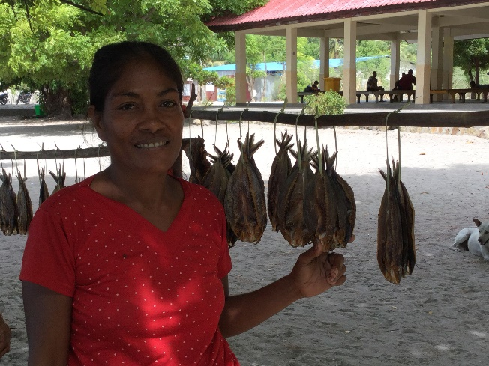

Report on field research conducted at Vila Maumeta, Beloi and Maquili communities on Ataúro Island, Timor-Leste (April 9 to May 21, 2018)

Cintia Gillam, PhD Student in Environmental Science (Applied Science), Saint Mary’s University, Halifax, Nova Scotia, Canada

Supervisor: Dr. Tony Charles

Acknowledgements
I would like to express my deepest gratitude to The Robin Rigby Trust for funding my research trip, and my supervisor, Dr. Tony Charles, for advising me while staying in Timor-Leste and through my PhD program, and my PhD committee members. Finally, my thankfulness to the research partners who contributed to my research without any financial compensation, in trust of my research. Many thanks to Fernando Anuno, Professor and Dean of Economics of the National University of Timor-Leste (UNTL) for his great support in connecting with communities and providing me with a letter of support of my research.
I also would like to like to thank the communities of Vila Maumeta, Beloi and Maquili, in special to the high school teacher Faustino Barros (Technical Vocational School of Ataúro) for his guidance around the community. I would also like to thank the interpreter Marcelo Belo, from the NGO Roman Luan for transporting me to communities and for Tetum-English translations of interviews.
Many thanks to the Fundação Oriente for providing me with amazing accommodation while I spent time in Dili, and in special to Graça Viegas for her kindness. I would also thank Dr. Helen Hill, professor at UNTL (Education) for connecting me with Timorese scholars, international students and other resources in Timor-Leste.
I’m especially grateful to the Xefe de Suco (village leader) Dato in Liquiçá Municipality, Oscar da Silva, for inviting me to the Suco Dato tara bandu ceremony held on April 13 and 14, 2018.

Introduction
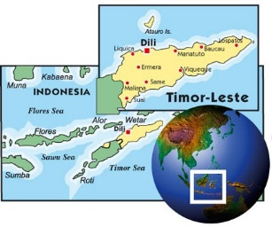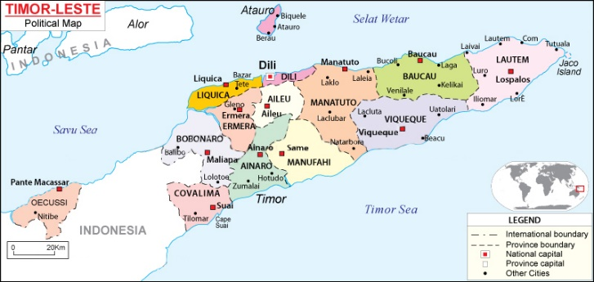
This field research trip was conducted at Vila Maumeta, Beloi and Maquili communities on Ataúro Island, Timor-Leste, is part of my PhD in Applied Science (Environmental Science) at Saint Mary’s University, Halifax, Nova Scotia, Canada, entitled: “Coastal and Marine Conservation in Timor-Leste: Assessing the Contribution of Tara Bandu Community Conservation Practices”. Tara bandu is the customary law that manages the relationship between humans and between humans and the environment. Local communities apply Traditional Ecological Knowledge (TEK) through tara bandu rules to implement closures in fishing and hunting in certain areas for ceremonial and conservation purposes. Tara bandu is much more holistic than conservation, but my research focuses on the conservation aspects of tara bandu.
The purpose of this research is to analyze how community conservation practices (tara bandu) help to meet ecological and human community wellbeing goals in these three coastal communities. The outcomes will be assessed through the measurement of indicators of conservation, human community wellbeing and ecological wellbeing. The development of the indicators will be based on the UN Sustainable Development Goals (SDGs) and its targets, SDG 2; SDG 3; SDG 14 and SDG 15.
- SDG 2: End hunger, achieve food security and improved nutrition and promote sustainable agriculture
- SDG 3: Ensure healthy lives and promote well-being for all at all ages
- SDG 14. Conserve and sustainably use the oceans, seas and marine resources for sustainable development
- SDG 15: Protect, restore and promote sustainable use of terrestrial ecosystems, sustainably manage forests, combat desertification, and halt and reverse land degradation and halt biodiversity loss.

Tara bandu rules guide community members about any certain species, methods and equipment to be used in coastal and inland areas. The community sets rules such as partial (and sometimes permanent) fisheries closures in certain areas to protect marine species that the community relies on, such as coral fishes, corals, seagrass, turtles and other marine species to help to increase fish catch and consequently, food security in the community.
Tara bandu is recognized in Timor-Leste’s constitution and integrated into forestry and watershed policy and strategy by Ministry of Agriculture and Fisheries (MAF) (Miyazawa, 2013, p. 16). The Timorese government has been closely working with district officers, community leaders and other groups to “preserve the environment and local livelihoods when they band together to protect local natural resources i.e. forest, lakes, rivers from destruction and pollution” by strengthening the practices of tara bandu in communities around the country (GoTL, 2012, p. 93).
Conservation Initiatives
Conservation International helped local communities on Ataúro Island to implement Marine Protected Areas through the Island. The community (Suco) of Vila Maumeta implemented their tara bandu general regulation in September 2017. This regulation was written by the General Direction of Fisheries, General Direction of the Forests, Coffee and Industrial Plants, General Direction Environment and Administrative Post Ataúro and Conservation International, and financial support from the Asian Development Bank. The tara bandu regulations for Beloi and Vila Maumeta have been written on the rules to regulate the area of each suco (village) and the natural resources, whether terrestrial or marine, to guarantee natural resource sustainability for the new generations. The Protected Area refers to marine and terrestrial regions that include the categories of biological criteria as places where there are flora and fauna and based on the formal law of protection. There are monetary penalties for people who harvest from the protected areas and the Suco Council applies prohibitions and recommends penalties when necessary, and contacts the Police for more serious matters involving violence.
Vila Maumeta has a Marine Protected Area (MPA), while Beloi has a Locally Managed Marine Area. In the Pacific region, the term ‘Locally Managed Marine Area’ (LMMA) is referred when marine resources are at least partially managed by communities’ (Rocliffe et al, 2014, p. 2). Locally managed marine areas involve co-management arrangements between coastal communities and other stakeholders such as government, NGOs, universities and the private sector.
The purpose of the MPA is to protect the biodiversity around Vila area and also to increase the food security and nutrition of the community through the increase of fish in the corals and seagrass inside and outside of the MPA. The community expects that the MPA will improve the community and fishers' lives in the long term. The community will apply tara bandu rules for the no-fishing areas of the MPA. Furthermore, Vila Ataúro Island suffers from droughts, affecting their crops and as a consequence, food security, so terrestrial coastal conservation is also important.
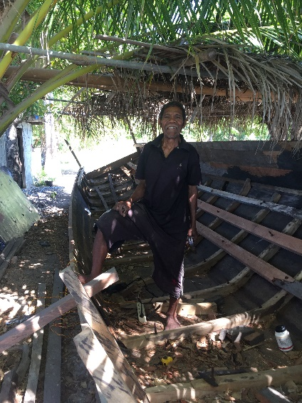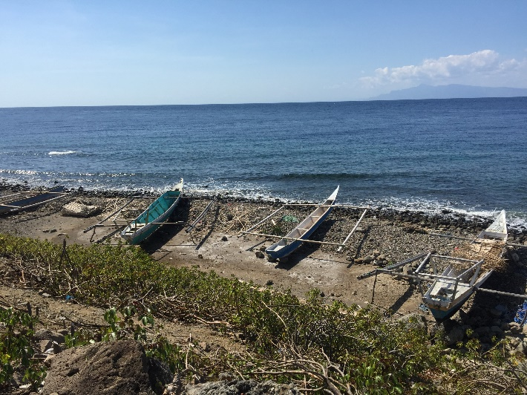
Fisher in Beloi and fishing boats in Maquili

General chronology of the data acquisition and Methodology
The methodology adopted included participant observation, informal conversations, video interviews and voice recorded semi-structured interviews with the help of an interpreter, Marcelo Belo (Tetum-English). I performed some interviews in Portuguese (my first language). Overwhelmingly amount of information was obtained with informal conversations during the period between April 11 and May 17, 2018.
The questionnaire contains 29 questions about species of fish harvested, hunting, Marine Protected Area (MPA), Locally Managed Marine Area (LMMA), including the extent of community involvement in co-management of Protected Areas (Pas), including terrestrial. I also included the perceptions from people of the importance of using tara bandu for the protected areas. I interviewed 25 people, fishers and farmers, men and women. Although many young people are fishers (mostly men), I mostly had the opportunity to interview people in their 30s, 40s, 50 and 60s due to power dynamics in the community. In addition, we had meeting in Maquili to map the resources and tara bandu in different villages, with 26 people present, with 20 men and 6 women. Another meeting was held with the Tara Bandu Committee in Vila Maumeta to discuss about collecting the tara bandu fee from tourists visiting the coral reefs of the community. Twenty people were present, 3 women and 17 men. The total number of research participants are 71 people, including interviews, meeting and focus group.
Problems Encountered on Field Trip
The official languages in Timor-Leste are Portuguese (my first language) and Tetum. Portuguese is not widely spoken in in Timor-Leste, which limited communication with many community members. Tetum is a Malayo-Polynesian language which is influenced by Portuguese. Indonesian and English are considered working languages. On Ataúro Island, Tetum is widely spoken, although there are other local languages. Other languages are spoken in the country are: Tetun Terik, Adabe, Atauran, Baikenu, Bekais, Bunak, Dadu’a, Fataluku, Galoli, Habun, Idalaka, Idate, Isni, Kairui, Kawaimina, Kemak, Lakalei, Lolein, Makalero, Sa’ani, Makasai, Makuva, Mambai, Midiki, Nanaek, Naueti, Rahesuk, Raklungu, Resuk, Tokodede and Waima’a (Timor-Leste Census, 2015).
I’ve decided not to research the community of Tutuala due to logistics and research constraints. Tutuala and Com are located in the Lautém Municipality in the far eastern tip of the country. I also felt that I didn’t fully engage with the community leaders as I did in Vila Maumeta (Ataúro Island) last year due to language barriers. It is too expensive to bring an interpreter with me all the time and pay for his/her accommodation, food, etc. while travelling in the eastern part of the country. In Lautem Municipality, the main spoken language is Fataluku, which is a Papuan language spoken by most residents of the Lautém Municipality. Although most people do not speak Portuguese in Timor-Leste in general, I’ve learnt a very basic Tetum that allows me to ‘survive’ while performing everyday tasks in the capital (Dili) and Ataúro Island. The Timorese who speak Portuguese are usually government employees, university professors, teachers, some NGO workers and the highly educated class in general.
As a researcher, often I had to assert myself in several situations due to the fact that I’m a woman and I deserve respect as a researcher. Timor-Leste is a very patriarchal society, and for this reason I was often forced to assert myself in a way that Robin Rigby Trust funding would help the whole community while dealing from pressure to help other groups who also need funding.
Successes Achieved
The community of Beloi has a system in place to collect $2 from each tourist who goes snorkeling and/or diving in the tara bandu Locally Managed Marine Area. Barry and Marcelina Hinton own the Eco-resort Barry’s Place in Beloi. Barry’s place organizes activities for tourists, including snorkel gear rental to visit the tara bandu protected areas (LMMAs).
I joined a snorkeling group of 7 people, mostly from Japan and Europe. We (each) paid for the boat trip, and $2 tara bandu fee. Barry’s Place receives the $2 from each tourist and sends the money to the Beloi Tara Bandu Committee. The Committee is saving the funds (tara bandu), and plans to invite the community to make a decision on how to use the money to improve the community, such as ameliorate the water supply for the community.
I shared my snorkeling experience from Barry's Place in Beloi with the Vila Maumeta Tara Bandu Committee during a meeting held on May 8, 2018 at the Xefe de Suco’s office. I had the kind support of Domingos Noronha, leader of the tara bandu group, and Faustino Barros (high school teacher) with Tetum-Portuguese translations during the meeting with the Xefe de Suco, Filipe Ximenes and the Vila Maumeta Tara Bandu Committee.
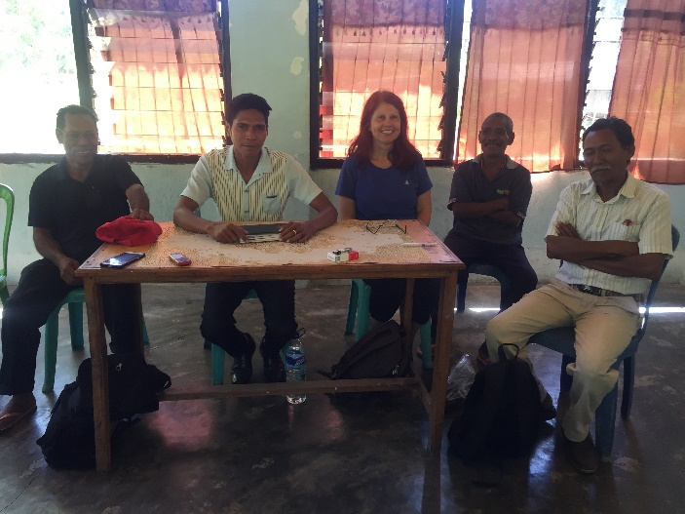
As snorkeling equipment is very expensive in Timor-Leste (and anywhere), it was necessary to carefully select who would own the equipment so the gear would be of help for the whole community. The women's cooperative which run guesthouse and restaurant 'Manukoko Rek' was excellent option to receive the snorkeling gear. I'm a guest at Manukoko Rek and see firsthand how the women are honest and hardworking they are, and their contributions for the community. For example, by efficiently running the guesthouse and restaurant, many tourists visit other community run projects, such as Biojoias and Boneca de Ataúro.
Sharing my snorkeling experience at Barry’s Place in Beloi helped the Xefe du Suco and the Tara Bandu Committee to decide to collaborate with the Manukoko Rek Women's Cooperative to collect the tara bandu fee for the community. With the women owning the equipment, the tara bandu group will collaborate with Manukoko Rek (Vila's hub for tourists) in connecting tourists to rent snorkeling gear to visit the corals in the tara bandu area. In exchange, the women will collect the $2.00 tara bandu fee for the Tara Bandu Committee and contact the Group's fishers who will take the tourists to the area for snorkeling.
Linking information on how to bring tourists to the Marine Protected Area will benefit the Vila Maumeta community because there is yet no system to collect the $2.00 tara bandu fee and use it to improve the community.
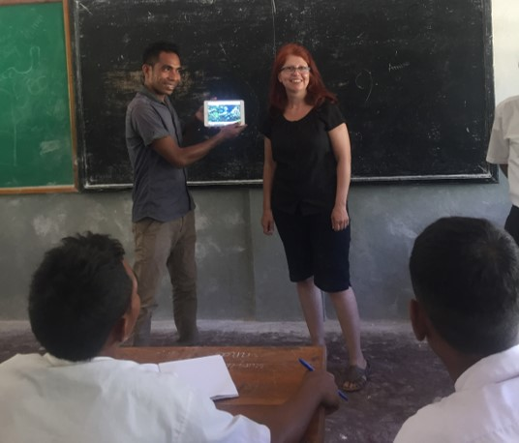
Teaching English at the Vocational High School of Ataúro Island in Vila Maumeta. The English teacher and I showed different IPAD videos of fish and marine animals and plants I filmed from several places such as Lisbon Oceanarium (Portugal); Biodome (Montreal), and Ripley’s Aquarium of Canada (Toronto). The students asked many questions about different fishes and habitats around the world.

What I have learned from the Field Trip
I have learned how capacity building is important to help organize disempowered communities. Also how conservation initiatives came from communities as a way to fight top-down development projects in the Island (Ataúro). Communities on Ataúro Island organized themselves with local and international NGOs against large-scale government projects including helipads and large hotels, which would compromise the eco-tourism model that communities support. Communities support the implementation of protected areas (terrestrial and marine) because if the Island were not protected, large tourism developers would employ their own people and keep locals out of work. For example, some local community members run homestays to receive tourists. In addition, ecotourism helps to keep local culture by allowing Ataúro residents to be employed in their own communities.
The community of Beloi is thriving in terms of tourism and conservation because of access to capacity building. For example, the community of Adara, which is part of Suco Beloi, successfully manages its own Locally Managed Marine Area (LMMA) with previous help from WorldFish. The NGO Blue Ventures collects data on the coral reefs in the Beloi LMMA to help with conservation projects.
The community of Maquili is not ready to implement a Marine Proacted area through tara bandu rules because the community has a small fishing area and a lot of fishers. Many community members apply traditional tara bandu rules in their farming areas to deter other people to steal their crops. They hung tara bandu items on the property as people won’t steal believing they will be cursed (sickness, etc.).
I’ve learned how to work with a local NGO and how to do research in another language. Timor-Leste is a small country with a population of 1,241,000 (Statistics Timor-Leste, 2015). The country holds hundreds of NGOs. I had no previous experience in working or closely observing how NGOs work overseas. Timor-Leste has good and bad NGOs. A great local NGO working on Ataúro Island is NaTerra. It promotes permaculture in local schools and other socio-ecological projects. NaTerra helped students to plant different varieties of vegetables, fruits and medicinal plants at the local elementary school in Vila Maumeta, on June 7th, 2018. The local NGO works with school children all over Ataúro Island with permaculture projects.
Photo: Levogildo Belarmino (NaTerra), at Vila Maumeta Elementary School (Leo’s Facebook Page)

Future Academic Plans
The main implication of the results of my PhD research is for user participation in fisheries and coastal management. It aims for evidence-based, informed policy development through research outcomes. The end users of the outcomes of my research are the Timorese government, international NGOs and coastal communities in Timor-Leste that work with conservation, such as Conservation International. This research can help the Timorese government (Ministry of Agriculture and Fisheries) to have much needed data on the indicators of human and ecosystem wellbeing as a result of tara bandu conservation practices. In addition, the outcomes will help the government to design policies that include traditional practices in ecotourism and fisheries development for community’s sustainable livelihoods.

Conclusions
Fishing and farming are important to support the livelihoods of people living in the communities of Ataúro Island. The communities of Vila Maumeta, Beloi and Maquili were chosen as case studies because artisanal fisheries and farming are essential for these fishers’ livelihoods. Small-scale fisheries are a considerable source of protein and livelihoods around the world, and very much so in these communities. In addition, farming is relevant because all fishers are farmers, but not all farmers are fishers in these communities.
The assessment of tara bandu practices to local conservation which will performed through the development of multiple indicators of conservation and governance, relating to the connections between ecological wellbeing (with emphasis on coral reef ecosystems), and the communities that rely on the reefs for their livelihoods, mainly through fisheries.
Some expected outcomes of adopting tara bandu conservation practices are:
• Improving natural resource management by including communities members in the decision-making process
• Making coastal resource management more affordable and culturally sensitive by engaging community in natural resource practices
More capacity building is necessary to improve local governance through support from state, NGO and private institutions to fully implement income collection from the protected areas. For example, the community of Beloi has more NGOs and other actors, such as Barry (Barry’s Place) who help the community with capacity buliding and collection of tara bandu fees from tourists who visit the reefs under tara bandu rules (LMMA). The community of Vila Maumeta is yet to implement the $2.00 collection fee, but now the Manukoko Rek women’s cooperative is ready to collaborate with the Tara Bandu Group to collect the fee and transter this fee to the group. It is important to note that often communities around the world do not work at the same pace as us, westerners, and change takes time. Especially in Timor-Leste, where culturally, projects and important decisions can only be implemented if everyone in the decision-making process approves them.
When communities are the main actors in natural resource management, it is their best interest to preserve nature as they rely on it for their subsistence. When NGOs, governments and other international bodies understand the historical context of conservation practices done by communities, and genuinely consider the needs of engaging these communities in bottom-up participatory projects where community management is the key for fisheries conservation, then the goals of conservation efforts will be met. There will be fewer conflicts between them, and real progress will take place in fisheries conservation. Gender and ethnic awareness will promote a more equitable use of natural resources within the community, and thereby, improving community-based conservation programs.

Photos from the Trip
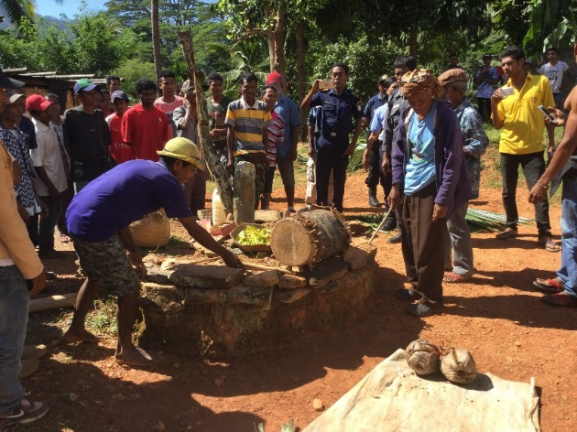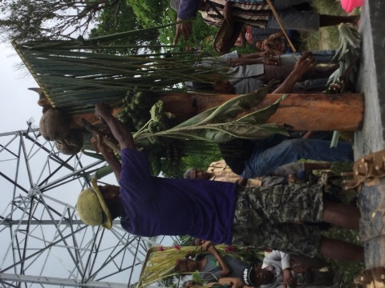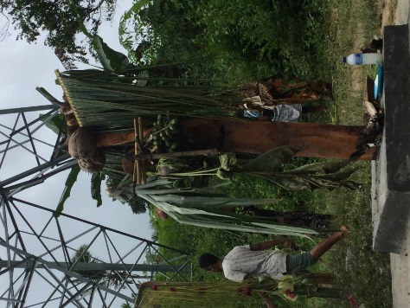
Preparing tara bandu ceremony at Suco Dato, Liquiçá Municipality. I was invited by the Xefe de Suco Oscar da Silva to attend the ceremony held on April 13 and 14, 2018.

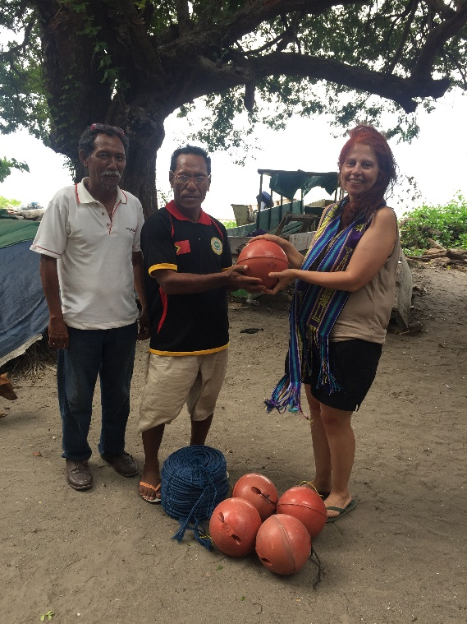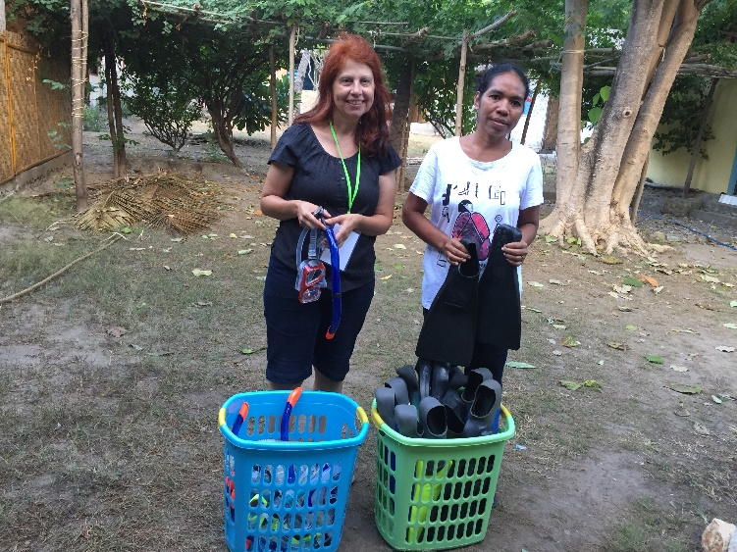
Donating buoys to the Tara Bandu Committee of Vila Maumeta and snorkeling gear to the Manukoko Rek Women’s Cooperative

Maps of Vila Maumeta and Beloi Protected Areas
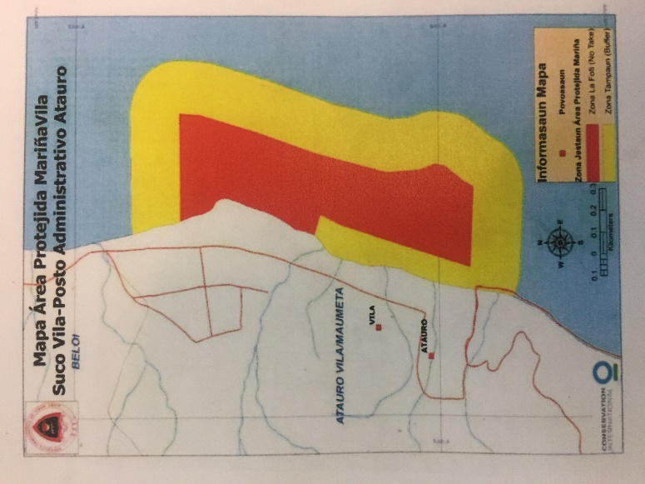
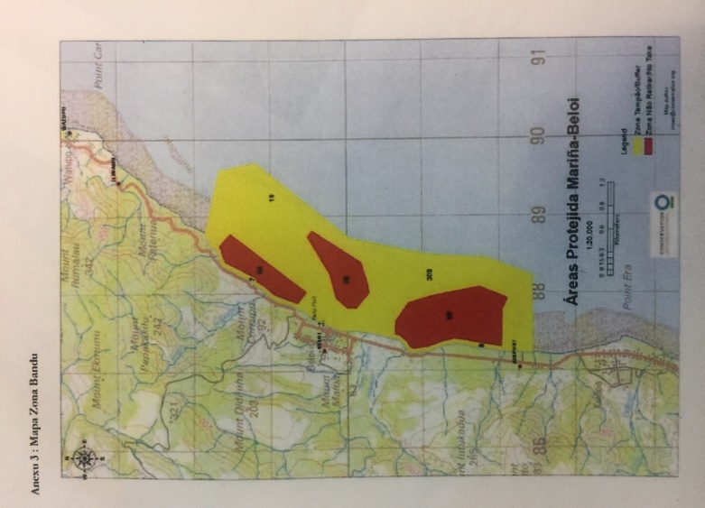
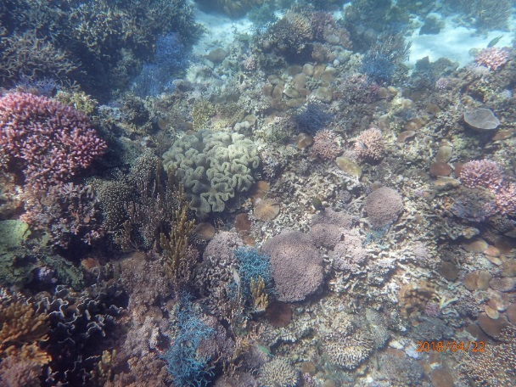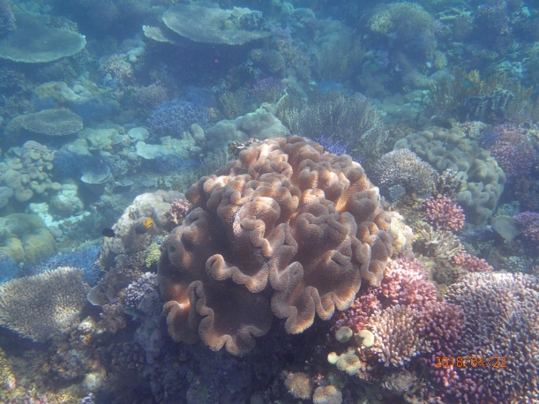
Corals in the Beloi Locally Managed Marine Area

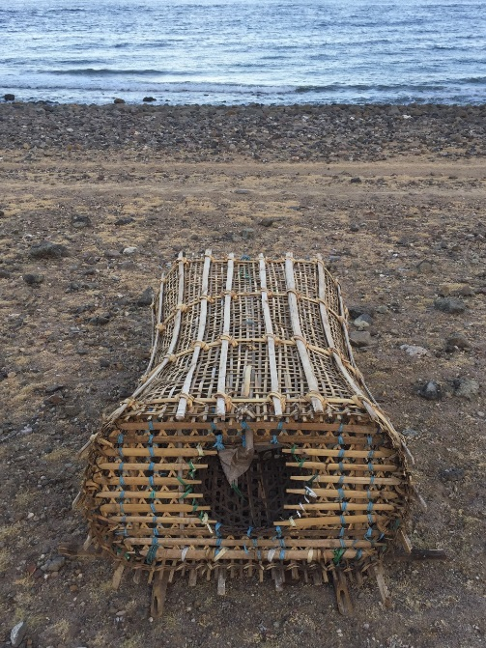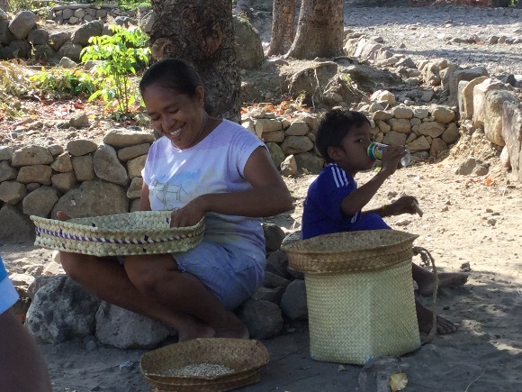
Traditional bamboo fishing trap and woman sorting out beans in Maquili

Expenses: April 9 to May 21, 2018
List of Expenses
Cintia’s Expenses |  | USD (Timor-Leste Currency) | CAD
Accommodation | Manukoko Rek Guesthouse (Vila Maumeta) | 383.00 | 496.64
Plane tickets | Return Airfare (Halifax to Bali* and Bali to Dili) |  | 1,637.93
Transportation | Return boat trips from Dili to Ataúro Island | $28.00 | 36.31
Transportation | Taxis |  | 76.30
Transportation | 3 boat trips from Maquili to Vila Maumeta | 20.00 | 25.93
Food | Per diem (40 days) |  | 800.00
Food for Focus Group in Maquili and Tara Bandu meeting in Vila Maumeta | Local, traditional foods such as seaweed, fish, etc. | 90.00 | 116.703
Translation Services |  | 225.00 | 291.76
Snorkeling gear for Manukoko Women’s Cooperative | Baskets, snorkels, diving masks, flippers |  | 690.31
Buoys | For Group Tara Bandu to demarcate MPA | 105.00 | 136.15
Gasoline and diesel | For motorcycle and boat | 57.25 | 74.24
Office supplies | (Notebook, printing, USBs, etc.) | 70.75 | 91.74
Other transportation and accommodation |  |  | 169.41
Total expenses |  |  | 4,643.42

*The Bali airport is known as the place to connect international travellers to small Indonesian islands and Timor-Leste.

References
East Timor Government (2018). Languages. http://easttimorgovernment.com/languages.htm
General Directorate of Fisheries, Forests, Coffe and Industrial Plants, the General Directorate for environment and Posto Ataúro, and Conservation International (2017). General Tara Bandu Regulation Suco Beloi, Posto Ataúro. Funding from the Asian Development Bank. Print.
General Directorate of Fisheries, Forests, Coffe and Industrial Plants, the General Directorate for environment and Posto Ataúro, and Conservation International (2017). General Tara Bandu Regulation Suco Vila Maumeta, Posto Ataúro. Funding from the Asian Development Bank. Print.
Government of Timor-Leste - GoTL (2012). Sustainable Development in Timor-Leste national report to the United Nations conference on sustainable development (UNCSD) on the run up to Rio+20. https://www.laohamutuk.org/econ/Rio20/TLReportRio20.pdf

James, F. (2017). Timor-Leste island community fears large-scale tourism development on Ataúro. http://www.abc.net.au/news/2017-07-17/timor-leste-island-community-fears-tourism-development/8713414
Miyazawa, N. (2013). Customary law and community-based natural resource management in post‐conflict Timor-Leste. University of Tokyo. In: Land and Post-Conflict Peacebuilding, ed. J. Unruh and R. C. Williams. London: Earthscan. http://environmentalpeacebuilding.org/assets/Documents/LibraryItem_000_Doc_167.pdf
Rocliffe, S., Peabody, S., Samoilys, M. & Hawkins, J. P. (2014) Towards a network of locally managed marine areas (LMMAs) in the Western Indian Ocean. PLoS ONE 9(7), 1-14e103000. doi:10.1371/journal.pone.0103000. https://www.ncbi.nlm.nih.gov/pmc/articles/PMC4108387/pdf/pone.0103000.pdf
Statistics Timor-Leste. Languages. http://www.statistics.gov.tl/language/

